ĐẠI HỌC HUẾ



KHOA KỸ THUẬT VÀ CÔNG NGHỆ



BÁO CÁO
ĐỒ ÁN
NĂM HỌC 2020-2021

Giảng viên hướng dẫn: Hồ Quốc Dũng
Lớp: DS & AI

Số phách
(Do hội đồng chấm thi ghi)

Thừa Thiên Huế, ngày …tháng 07 năm 2021
ĐẠI HỌC HUẾ

KHOA KỸ THUẬT VÀ CÔNG NGHỆ


(MẪU BÌA PHỤ)
BÁO CÁO
ĐỒ ÁN
NĂM HỌC 2020-2021
Giảng viên hướng dẫn: Hồ Quốc Dũng
Lớp: DS & AI
Sinh viên thực hiện: Phan Thế Minh Châu
(ký tên và ghi rõ họ tên)

Số phách
(Do hội đồng chấm thi ghi)

Thừa Thiên Huế, ngày …thán 07 năm 2021

BÀI 1: Tháp Hà Nội
- Python:
Code:
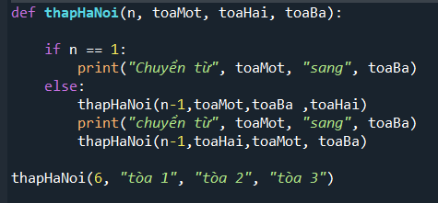
- R:
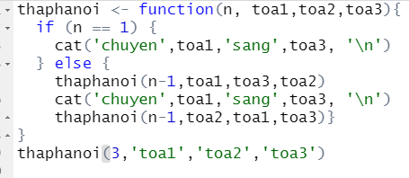
- Kết quả: trả về một dãy danh sách các bước thực hiện sắp xếp các cột

BÀI 2: Ước chung lớn nhất
- Python
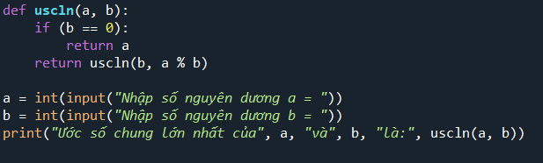
- R
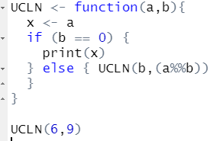
- Kết quả: Tìm ra được ước chung lớn nhất của hai số nhập từ bàn phím
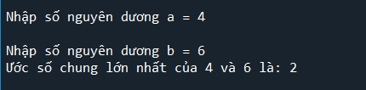

BÀI 3: Tính giai thừa của 1 số
- Python
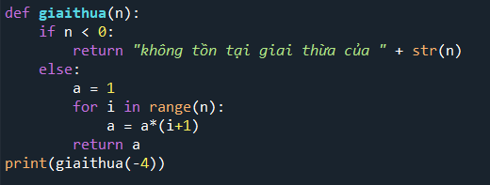
- R
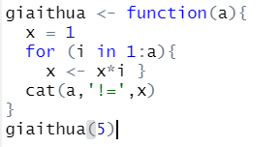
- Kết quả: trả về giai thừa của số nhập từ bàn phím
BÀI 4: Mã đi tuần
- Python
n = 8
def isSafe(x, y, board):
if(x >= 0 and y >= 0 and x < n and y < n and board[x][y] == -1):
return True
return False

def printSolution(n, board):
for i in range(n):
for j in range(n):
print(board[i][j], end=' ')
print()

def solveKT(n):

# Initialization of Board matrix
board = [[-1 for i in range(n)]for i in range(n)]

# move_x and move_y define next move of Knight.
# move_x is for next value of x coordinate
# move_y is for next value of y coordinate
move_x = [2, 1, -1, -2, -2, -1, 1, 2]
move_y = [1, 2, 2, 1, -1, -2, -2, -1]

# Since the Knight is initially at the first block
board[0][0] = 0

# Step counter for knight's position
pos = 1

# Checking if solution exists or not
if(not solveKTUtil(n, board, 0, 0, move_x, move_y, pos)):
print("Solution does not exist")
else:
printSolution(n, board)

def solveKTUtil(n, board, curr_x, curr_y, move_x, move_y, pos):

if(pos == n**2):
return True

# Try all next moves from the current coordinate x, y
for i in range(8):
new_x = curr_x + move_x[i]
new_y = curr_y + move_y[i]
if(isSafe(new_x, new_y, board)):
board[new_x][new_y] = pos
if(solveKTUtil(n, board, new_x, new_y, move_x, move_y, pos+1)):
return True

# Backtracking
board[new_x][new_y] = -1
return False

# Driver Code
if __name__ == "__main__":

# Function Call
solveKT(n)
- R
valid_move <- function (x, y, board) {
x >= 1 && y >= 1 && x <= 8 && y <= 8 && board[x, y] == -1
}

solve <- function (board, curr_x, curr_y, move_x, move_y, pos) {
if (pos == 64) {
return (board)
}
for (i in seq(1, 8)) {
new_x = curr_x + move_x[i]
new_y = curr_y + move_y[i]

if (valid_move(new_x, new_y, board)) {
board[new_x, new_y] = pos
result <- solve(board, new_x, new_y, move_x, move_y, (pos + 1))
if (!is.null(result)) {
return (result)
}
board[new_x, new_y] = -1
}
}
# Return NULL
# As this is the last result of the function, you don't need to write return (NULL)
NULL
}
final_board <- solve(
board = matrix(
c(0, rep_len(-1, 63)),
nrow = 8, ncol = 8,
byrow = TRUE
),
curr_x = 1,
curr_y = 1,
move_x = c(2, 1,-1,-2,-2,-1, 1, 2),
move_y = c(1, 2, 2, 1,-1,-2,-2,-1),
pos = 1
)
final_board
- Kết quả: trả về một mảng vector 8x8 mỗi số tương ứng với bước đi trên bàn cờ
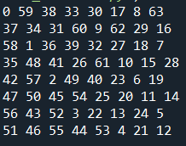
BÀI 5: 8 quân hậu
- Python
class NQueens:
def __init__(self, size):
# Store the puzzle (problem) size and the number of valid solutions
self.size = size
self.solutions = 0
self.solve()

def solve(self):
positions = [-1] * self.size
self.put_queen(positions, 0)
print("Found", self.solutions, "solutions.")

def put_queen(self, positions, target_row):
if target_row == self.size:
self.show_full_board(positions)
self.solutions += 1
else:
# For all N columns positions try to place a queen
for column in range(self.size):
# Reject all invalid positions
if self.check_place(positions, target_row, column):
positions[target_row] = column
self.put_queen(positions, target_row + 1)

def check_place(self, positions, ocuppied_rows, column):
for i in range(ocuppied_rows):
if positions[i] == column or \
positions[i] - i == column - ocuppied_rows or \
positions[i] + i == column + ocuppied_rows:

return False
return True

def show_full_board(self, positions):
for row in range(self.size):
line = ""
for column in range(self.size):
if positions[row] == column:
line += "Q "
else:
line += ". "
print(line)
print("\n")

def show_short_board(self, positions):
line = ""
for i in range(self.size):
line += str(positions[i]) + " "
print(line)

def main():
NQueens(8)

if __name__ == "__main__":
# execute only if run as a script
main()
- R
install.packages("tidyverse")
library(tidyverse)
f=function(q){L=length(q)
if(L==8){return(q)}
flatten(map(setdiff(1:8,c(q,c(q+L:1,q-L:1))),~f(c(q,.x))))}
s=data.frame(c=unlist(f(c())),r=1:8,x=rep(1:92,e=8))
ggplot(s)+geom_tile(aes(r,c))+facet_wrap(~x)

#-----------------------------------------------------------------------------
#' Try and place a queen given the queens we have on the board so far
#'
#' @param queens column placement of queens so far. The index within this list
#' is the row, and the value is the column.
#'
#-----------------------------------------------------------------------------
place_queen <- function(queens) {
# If there are 8 queens placed, then this must be a solution.
if (length(queens) == 8) {
cat("Solution: ", paste(queens, collapse=", "), "\n")
return()
}

# Need to figure out where I can place a queen in the next row.
# Drop all columns that have already been taken - since we
# can't place a queen below an existing queen
possible_placements <- setdiff(1:8, queens)

# For each queen already on the board, find the diagonal
# positions that it can see in this row.
diag_offsets <- seq(length(queens), 1)
diags <- c(queens + diag_offsets, queens - diag_offsets)
diags <- diags[diags > 0 & diags < 9]

# Drop these diagonal columns from possible placements
possible_placements <- setdiff(possible_placements, diags)

# For each possible placement, try and place a queen
walk(possible_placements, ~place_queen(c(queens, .x)))
}

# Start with no queens placed
place_queen(c())
- Kết quả: trả về 92 kết quả vị trí của 8 quân hậu
BÀI 6: Danh sách liên kết đơn
- Python
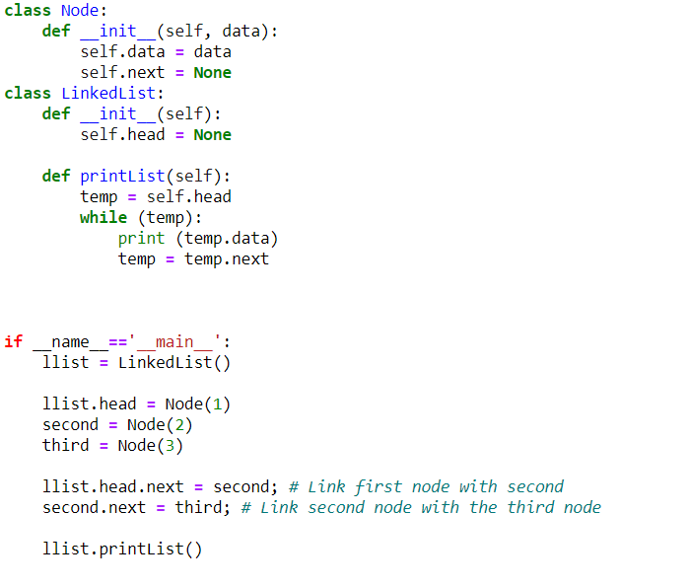
- R
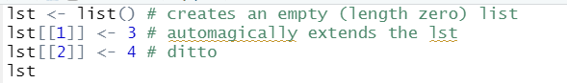
BÀI 7: Danh sách liên kết kép
- Python
class Node:

# Constructor to create a new node
def __init__(self, data):
self.data = data
self.next = None
self.prev = None

# Class to create a Doubly Linked List
class DoublyLinkedList:

# Constructor for empty Doubly Linked List
def __init__(self):
self.head = None

# Given a reference to the head of a list and an
# integer, inserts a new node on the front of list
def push(self, new_data):

# 1. Allocates node
# 2. Put the data in it
new_node = Node(new_data)

# 3. Make next of new node as head and
# previous as None (already None)
new_node.next = self.head

# 4. change prev of head node to new_node
if self.head is not None:
self.head.prev = new_node

# 5. move the head to point to the new node
self.head = new_node

# Given a node as prev_node, insert a new node after
# the given node
def insertAfter(self, prev_node, new_data):

# 1. Check if the given prev_node is None
if prev_node is None:
print("the given previous node cannot be NULL")
return

# 2. allocate new node
# 3. put in the data
new_node = Node(new_data)

# 4. Make net of new node as next of prev node
new_node.next = prev_node.next

# 5. Make prev_node as previous of new_node
prev_node.next = new_node

# 6. Make prev_node ass previous of new_node
new_node.prev = prev_node

# 7. Change previous of new_nodes's next node
if new_node.next is not None:
new_node.next.prev = new_node

# Given a reference to the head of DLL and integer,
# appends a new node at the end
def append(self, new_data):

# 1. Allocates node
# 2. Put in the data
new_node = Node(new_data)

# 3. This new node is going to be the last node,
# so make next of it as None
new_node.next = None

# 4. If the Linked List is empty, then make the
# new node as head
if self.head is None:
new_node.prev = None
self.head = new_node
return

# 5. Else traverse till the last node
last = self.head
while(last.next is not None):
last = last.next

# 6. Change the next of last node
last.next = new_node

# 7. Make last node as previous of new node
new_node.prev = last

return

# This function prints contents of linked list
# starting from the given node
def printList(self, node):

print("\nTraversal in forward direction")
while(node is not None):
print(" % d" %(node.data))
last = node
node = node.next

print("\nTraversal in reverse direction")
while(last is not None):
print(" % d" %(last.data), last = last.prev)

# Driver program to test above functions

# Start with empty list
llist = DoublyLinkedList()

# Insert 6. So the list becomes 6->None
llist.append(6)

# Insert 7 at the beginning.
# So linked list becomes 7->6->None
llist.push(7)

# Insert 1 at the beginning.
# So linked list becomes 1->7->6->None
llist.push(1)

# Insert 4 at the end.
# So linked list becomes 1->7->6->4->None
llist.append(4)

# Insert 8, after 7.
# So linked list becomes 1->7->8->6->4->None
llist.insertAfter(llist.head.next, 8)

print("Created DLL is: ", llist.printList(llist.head))
- R
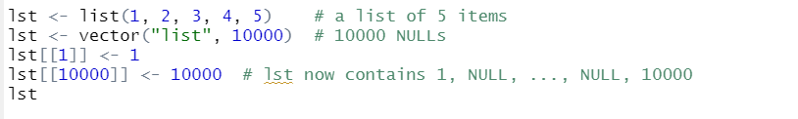
BÀI 8: Cài đặt ngăn xếp - stack
- Python
class Node:
def __init__(self, value):
self.value = value
self.next = None

class Stack:

# Initializing a stack.
# Use a dummy node, which is
# easier for handling edge cases.
def __init__(self):
self.head = Node("head")
self.size = 0

# String representation of the stack
def __str__(self):
cur = self.head.next
out = ""
while cur:
out += str(cur.value) + "->"
cur = cur.next
return out[:-3]

# Get the current size of the stack
def getSize(self):
return self.size

# Check if the stack is empty
def isEmpty(self):
return self.size == 0

# Get the top item of the stack
def peek(self):

# Sanitary check to see if we
# are peeking an empty stack.
if self.isEmpty():
raise Exception("Peeking from an empty stack")
return self.head.next.value

# Push a value into the stack.
def push(self, value):
node = Node(value)
node.next = self.head.next
self.head.next = node
self.size += 1

# Remove a value from the stack and return.
def pop(self):
if self.isEmpty():
raise Exception("Popping from an empty stack")
remove = self.head.next
self.head.next = self.head.next.next
self.size -= 1
return remove.value

# Driver Code
if __name__ == "__main__":
stack = Stack()
for i in range(1, 11):
stack.push(i)
print(f"Stack: {stack}")

for _ in range(1, 6):
remove = stack.pop()
print(f"Pop: {remove}")
print(f"Stack: {stack}")
- R
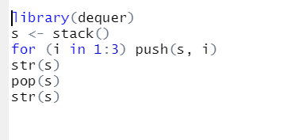
- Kết quả: lấy ra phần tử trong danh sách đồng thời xóa nó
BÀI 9: Hàng đợi queue
- Python
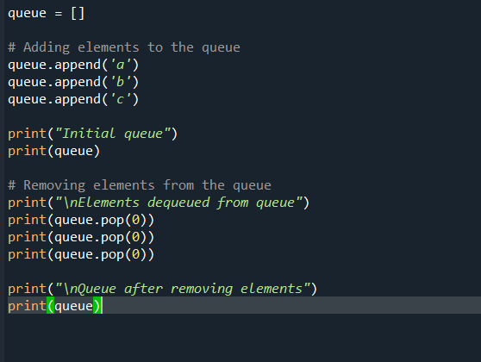
- R
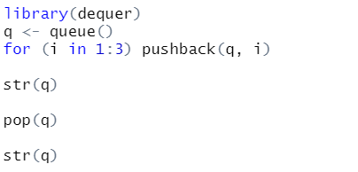
BÀI 10 - 11: Duyệt cây thứ tự trước - sau
- Python
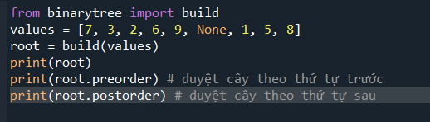
- R
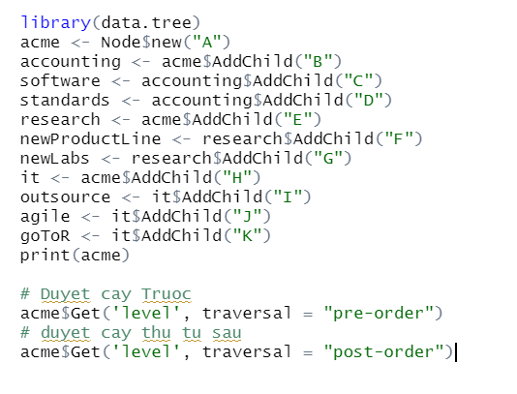
BÀI 12: Đồ thị vô hướng
- Python
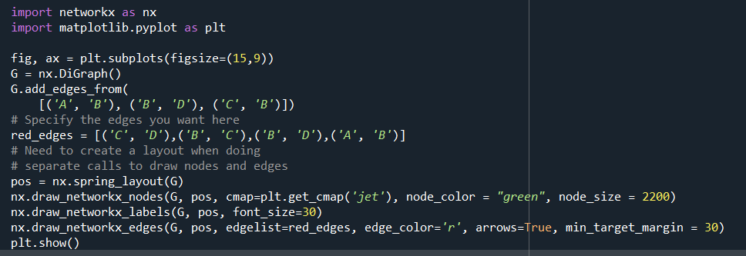
- R
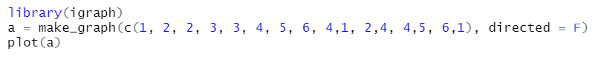
- Kết quả:
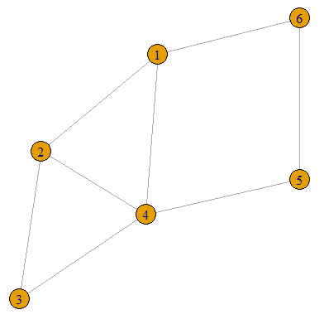
BÀI 13: Đồ thị có hướng
- Python
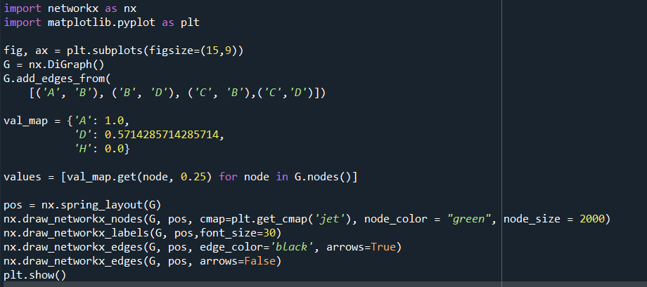
- R
- Kết quả:
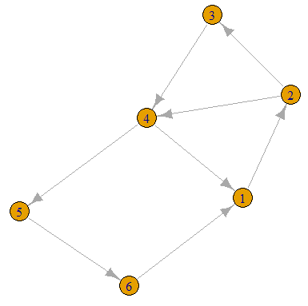
BÀI 14: Sắp xếp chọn
- Python
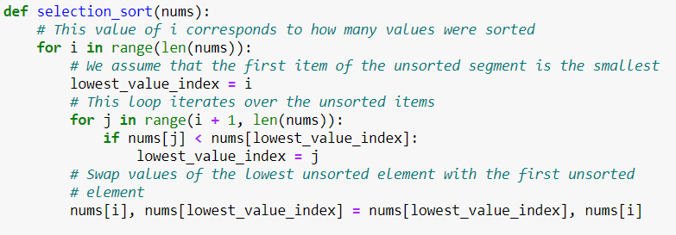
- R
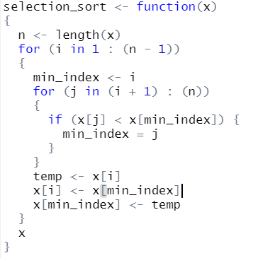
BÀI 15: sắp xếp chèn
- Python
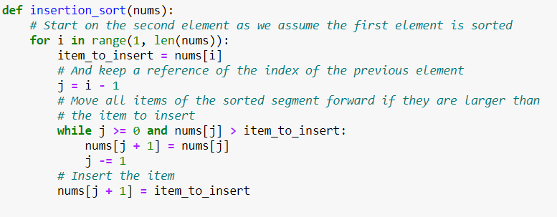
- R
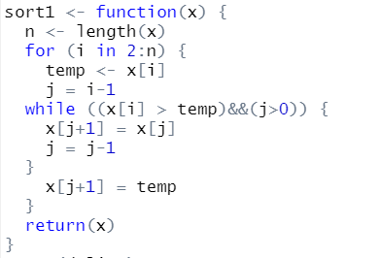
BÀI 16: sắp xếp nổi bọt
- Python
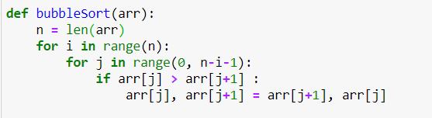
- R
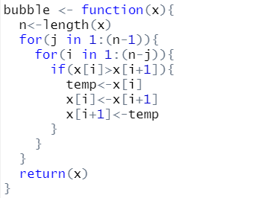
BÀI 17: quick sort
- Python
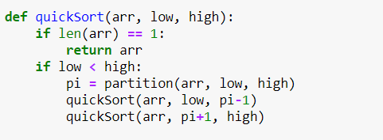
- R
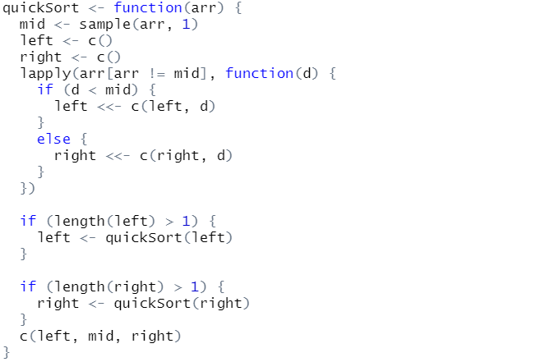
BÀI 18: heap sort
- Python
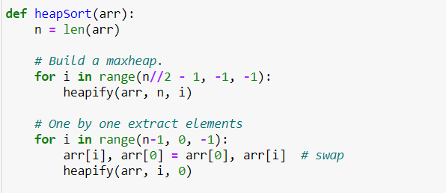
- R
heap.building<-function(vec)
{
len=length(vec)
heap=vec
for (j in len:1)
{
heap=modify.heap(heap,j)
}
return(heap)
}

is.heap<-function(heap,root_i)
{
i=root_i
res=T
while(2*i<=length(heap)&res)
{
son=c(heap[2*i],heap[2*i+1])
son=son[!is.na(son)]
res=all(heap[i]<=son)
i=i+1
}
return(res)
}

modify.heap<-function(heap,root_i)
{
len=length(heap)
flag=1

while (root_i*2<=len&&flag==1)
{
left_i=root_i*2
right_i=root_i*2+1
flag=0
son=c(heap[left_i],heap[right_i])
son=son[!is.na(son)]
min_ind=which.min(son)
if (heap[root_i]>son[min_ind])
{
flag=1
heap_ind=c(left_i,right_i)[min_ind]

tmp=heap[heap_ind]
heap[heap_ind]=heap[root_i]
heap[root_i]=tmp

root_i=heap_ind
}
}
return(heap)
}

heap.sort<-function(heap)
{
sorted=NULL
len=length(heap)
while(len>0)
{
sorted=c(sorted,heap[1])
len=length(heap)
heap[1]=heap[len]
heap=heap[1:(len-1)]
heap=modify.heap(heap,root_i=1)
len=len-1
}
return(sorted)
}
BÀI 19: merge sort
- Python
def mergeSort(myList):
if len(myList) > 1:
mid = len(myList) // 2
left = myList[:mid]
right = myList[mid:]

# Recursive call on each half
mergeSort(left)
mergeSort(right)

# Two iterators for traversing the two halves
i = 0
j = 0

# Iterator for the main list
k = 0

while i < len(left) and j < len(right):
if left[i] <= right[j]:
# The value from the left half has been used
myList[k] = left[i]
# Move the iterator forward
i += 1
else:
myList[k] = right[j]
j += 1
# Move to the next slot
k += 1

# For all the remaining values
while i < len(left):
myList[k] = left[i]
i += 1
k += 1

while j < len(right):
myList[k]=right[j]
j += 1
k += 1
- R
